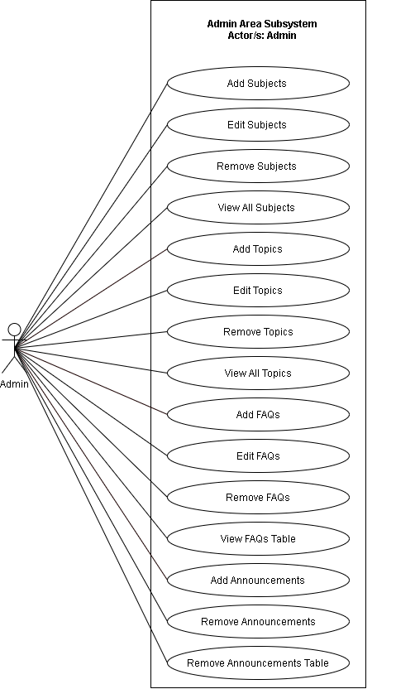

**Figure 5. Use Case Diagram for Admin Area Subsystem**

Figure 5 shows the Use case diagram for Admin Area Subsystem. The illustration shows the capabilities of Admin. The admin can have access to Add Subjects, Edit Subjects, Remove Subjects, View All Subjects, Add Topics, Edit Topics, Remove Topics, View All Topics, Add FAQ’s, Remove FAQ’s, View FAQ’s table, Add Announcements, Remove Announcements and Remove Announcements Table.

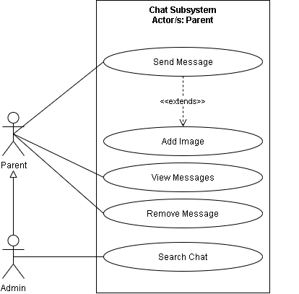

**Figure 7. Use Case Diagram for Chat Subsystem**

Figure 7 shows the Use case diagram for Admin Area Subsystem. The illustration shows the capabilities of Parent and Admin. The Admin have access to Send Message, View Messages, Remove Messages, and Search Chat. The Parent can access all the capabilities of Admin except for Search Chat.

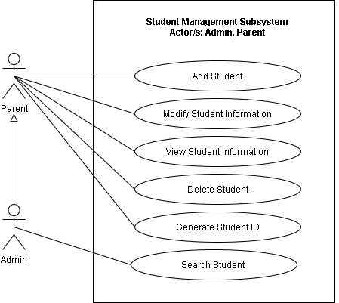

**Figure 1. Use Case Diagram for Student Management Subsystem**

Figure 1 shows the Use case diagram for Student Management Subsystem. The illustration shows the capabilities of Parent and Admin. The Admin have access to Add Student, Modify Student Information, View Student Information, Delete Student, and Generate Student ID. The Parent can access all the capabilities of Admin except for Search Student.

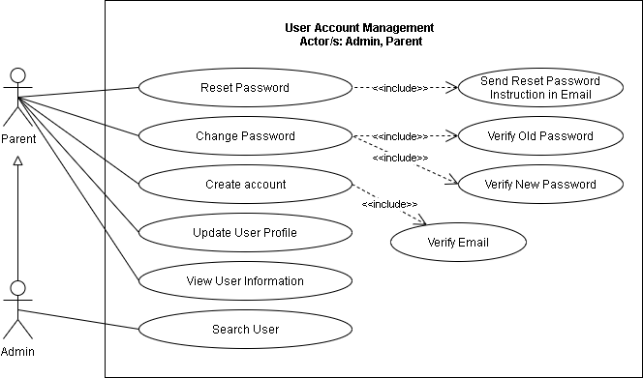

**Figure 2. Use Case Diagram for User Account Management**

Figure 2 shows the Use case diagram for User Account Management. The illustration shows the capabilities of Parent and Admin. The Admin have access to Reset Password, Change Password, Create Account, Update User Profile, and View User Information. The Parent can access all the capabilities of Admin except for Search User.

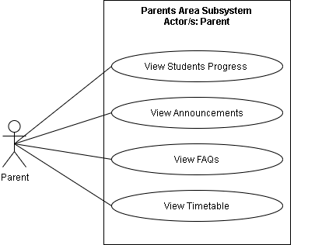

**Figure 3. Use Case Diagram for Parents Area Subsystem**

Figure 3 shows the Use case diagram for Parents Area Subsystem. The illustration shows the capabilities of Parent. The Parent have access to View Students Progress, View Announcements, View FAQs, and View Timetable.

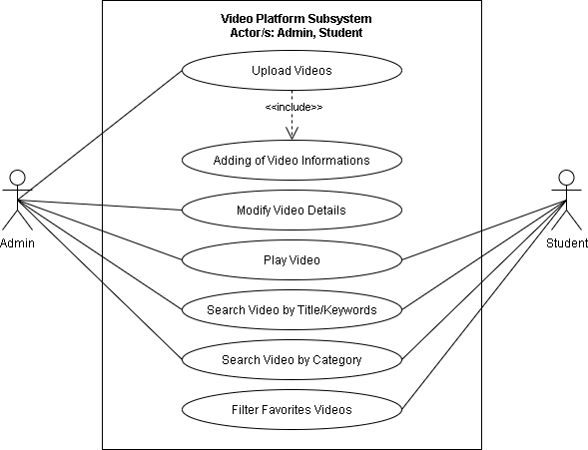

**Figure 4. Use Case Diagram for Video Platform Subsystem**

Figure 4 shows the Use case diagram for Parents Area Subsystem. The illustration shows the capabilities of Admin and Parent. The Admin have access to Upload Videos, Modify Video Details, Play Video, Search Video by Title/Keywords, and Search Video by Category. The Parent have access to Play Video, Search Video by Title/Keywords, Search Video by Category, and Filter Favorite Videos.

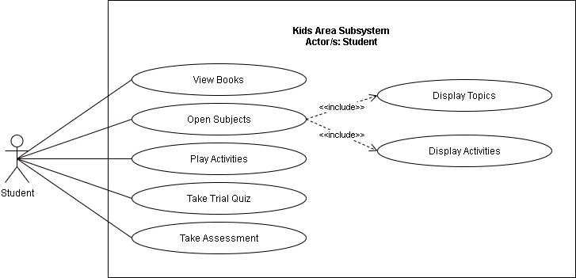

**Figure 6. Use Case Diagram for Kids Area Subsystem**

Figure 6 shows the Use case diagram for Kids Area Subsystem. The illustration shows the capabilities of Student. The Student have access to View Books, Open Subjects, Play Activities, Take Trial Quiz and Take Assessment.